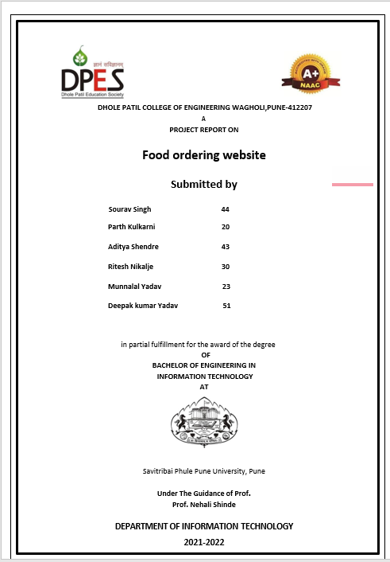

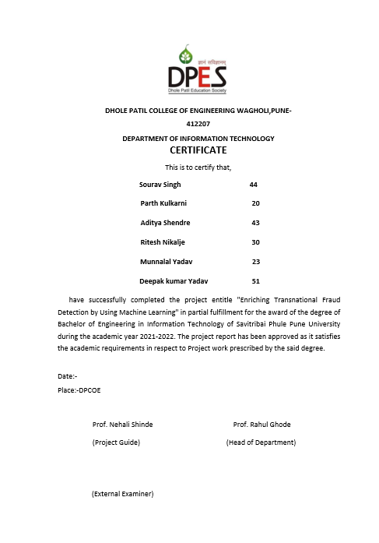

**INTRODUCTION**

We have made a food ordering website named as wowfood. We have taken websites such as

Zomato, Swiggy, Foodpanda as reference to build our own e-commerce website.

Our main Moto of the project was to accumulate or bring most of the restaurant chains on

E-commerce platform so that there will be no space for problems such as waiting for dining,

Services, order waiting for hours, etc.

Uniqueness of this project consists of Rating, cash on delivery, following of covid protocols,

And as well as healthiness of the food environment so that there will be no worry left for

Customers.

**Scope of the project**

***Current scope*** of the project is to bring all the near by restaurants on a single digital platform

So that there will be more business on small scale as well as wide scale. This will help us to build

And grow our own successful working eco system.

***Future Scope***

1.To add verities of food categories

2.For further growth we can add groceries section.

3.To add crypto as future payment option.

**System Requirement Software**

**MySQL:-**

**It is an**[**open-source**](https://en.wikipedia.org/wiki/Open-source_software)[**relational database management system**](https://en.wikipedia.org/wiki/Relational_database_management_system)**(RDBMS).**[**[5]**](https://en.wikipedia.org/wiki/MySQL#cite_note-whatismysql-5)[**[6]**](https://en.wikipedia.org/wiki/MySQL#cite_note-6)**Its name is a combination of "My", the name of co-founder**[**Michael Widenius**](https://en.wikipedia.org/wiki/Michael_Widenius)**'s daughter,**[**[7]**](https://en.wikipedia.org/wiki/MySQL#cite_note-7)**and "**[**SQL**](https://en.wikipedia.org/wiki/SQL)**", the abbreviation for**[**Structured Query Language**](https://en.wikipedia.org/wiki/Structured_Query_Language)**. A**[**relational database**](https://en.wikipedia.org/wiki/Relational_database)**organizes data into one or more data tables in which data may be related to each other; these relations help structure the data. SQL is a language programmers use to create, modify and extract data from the relational database, as well as control user access to the database. In addition to relational databases and SQL, an RDBMS like MySQL works with an**[**operating system**](https://en.wikipedia.org/wiki/Operating_system)**to implement a relational database in a computer's storage system, manages users, allows for network access and facilitates testing database integrity and creation of backups.**

**MySQL is**[**free and open-source software**](https://en.wikipedia.org/wiki/Free_and_open-source_software)**under the terms of the**[**GNU General Public License**](https://en.wikipedia.org/wiki/GNU_General_Public_License)**, and is also available under a variety of**[**proprietary**](https://en.wikipedia.org/wiki/Proprietary_software)**licenses. MySQL was owned and sponsored by the**[**Swedish**](https://en.wikipedia.org/wiki/Sweden)**company**[**MySQL AB**](https://en.wikipedia.org/wiki/MySQL_AB)**, which was bought by**[**Sun Microsystems**](https://en.wikipedia.org/wiki/Sun_Microsystems)**(now**[**Oracle Corporation**](https://en.wikipedia.org/wiki/Oracle_Corporation)**).**[**[8]**](https://en.wikipedia.org/wiki/MySQL#cite_note-sunacquire-8)**In 2010, when Oracle acquired Sun, Widenius**[**forked**](https://en.wikipedia.org/wiki/Fork_(software_development))**the**[**open-source**](https://en.wikipedia.org/wiki/Open-source)**MySQL project to create**[**MariaDB**](https://en.wikipedia.org/wiki/MariaDB)**.**

**PHP:-**

**is a**[**general-purpose**](https://en.wikipedia.org/wiki/General-purpose_programming_language)[**scripting language**](https://en.wikipedia.org/wiki/Scripting_language)**geared toward**[**web development**](https://en.wikipedia.org/wiki/Web_development)**.**[**[7]**](https://en.wikipedia.org/wiki/PHP#cite_note-7)**It was originally created by Danish-Canadian**[**programmer**](https://en.wikipedia.org/wiki/Programmer)[**Rasmus Lerdorf**](https://en.wikipedia.org/wiki/Rasmus_Lerdorf)**in 1994.**[**[8]**](https://en.wikipedia.org/wiki/PHP#cite_note-History_of_PHP-8)**The PHP**[**reference implementation**](https://en.wikipedia.org/wiki/Reference_implementation)**is now produced by The PHP Group.**[**[9]**](https://en.wikipedia.org/wiki/PHP#cite_note-about_PHP-9)**PHP originally stood for *Personal Home Page*,**[**[8]**](https://en.wikipedia.org/wiki/PHP#cite_note-History_of_PHP-8)**but it now stands for the**[**recursive initialism**](https://en.wikipedia.org/wiki/Recursive_initialism)***PHP: Hypertext Preprocessor*.**[**[10]**](https://en.wikipedia.org/wiki/PHP#cite_note-10)

**PHP code is usually processed on a**[**web server**](https://en.wikipedia.org/wiki/Web_server)**by a PHP**[**interpreter**](https://en.wikipedia.org/wiki/Interpreter_(computing))**implemented as a**[**module**](https://en.wikipedia.org/wiki/Plugin_(computing))**, a**[**daemon**](https://en.wikipedia.org/wiki/Daemon_(computing))**or as a**[**Common Gateway Interface**](https://en.wikipedia.org/wiki/Common_Gateway_Interface)**(CGI) executable. On a web server, the result of the**[**interpreted**](https://en.wikipedia.org/wiki/Interpreter_(computing))**and executed PHP code – which may be any type of data, such as generated**[**HTML**](https://en.wikipedia.org/wiki/HTML)**or**[**binary**](https://en.wikipedia.org/wiki/Binary_number)**image data – would form the whole or part of an**[**HTTP**](https://en.wikipedia.org/wiki/Hypertext_Transfer_Protocol)**response. Various**[**web template systems**](https://en.wikipedia.org/wiki/Web_template_system)**, web**[**content management systems**](https://en.wikipedia.org/wiki/Content_management_system)**, and**[**web frameworks**](https://en.wikipedia.org/wiki/Web_framework)**exist which can be employed to orchestrate or facilitate the generation of that response. Additionally, PHP can be used for many programming tasks outside the web context, such as standalone**[**graphical applications**](https://en.wikipedia.org/wiki/Graphical_user_interface)[**[11]**](https://en.wikipedia.org/wiki/PHP#cite_note-11)**and**[**robotic**](https://en.wikipedia.org/wiki/Robotics)[**drone**](https://en.wikipedia.org/wiki/Unmanned_aerial_vehicle)**control.**[**[12]**](https://en.wikipedia.org/wiki/PHP#cite_note-12)**PHP code can also be directly executed from the**[**command line**](https://en.wikipedia.org/wiki/Command-line_interface)**.**

**The standard PHP interpreter, powered by the**[**Zend Engine**](https://en.wikipedia.org/wiki/Zend_Engine)**, is**[**free software**](https://en.wikipedia.org/wiki/Free_software)**released under the**[**PHP License**](https://en.wikipedia.org/wiki/PHP_License)**. PHP has been widely ported and can be deployed on most web servers on a variety of**[**operating systems**](https://en.wikipedia.org/wiki/Operating_system)**and**[**platforms**](https://en.wikipedia.org/wiki/Computing_platform)**.**[**[13]**](https://en.wikipedia.org/wiki/PHP#cite_note-foundations-13)

**Xaamp:-**

XAMPP ([/ˈzæmp/](https://en.wikipedia.org/wiki/Help:IPA/English) or [/ˈɛks.æmp/](https://en.wikipedia.org/wiki/Help:IPA/English))[[2]](https://en.wikipedia.org/wiki/XAMPP#cite_note-kaiseidlerinterview-2) is a [free and open-source](https://en.wikipedia.org/wiki/Free_and_open-source) [cross-platform](https://en.wikipedia.org/wiki/Cross-platform) [web server](https://en.wikipedia.org/wiki/Web_server) [solution stack](https://en.wikipedia.org/wiki/Solution_stack) package developed by Apache Friends,[[2]](https://en.wikipedia.org/wiki/XAMPP#cite_note-kaiseidlerinterview-2) consisting mainly of the [Apache HTTP Server](https://en.wikipedia.org/wiki/Apache_HTTP_Server), [MariaDB](https://en.wikipedia.org/wiki/MariaDB) [database](https://en.wikipedia.org/wiki/Database), and [interpreters](https://en.wikipedia.org/wiki/Interpreter_(computing)) for scripts written in the [PHP](https://en.wikipedia.org/wiki/PHP) and [Perl](https://en.wikipedia.org/wiki/Perl) [programming languages](https://en.wikipedia.org/wiki/Programming_language).[[3]](https://en.wikipedia.org/wiki/XAMPP#cite_note-x_mariadb-3)[[4]](https://en.wikipedia.org/wiki/XAMPP#cite_note-4) Since most actual web server deployments use the same components as XAMPP, it makes transitioning from a local test server to a live server possible.

XAMPP's ease of deployment means a [WAMP](https://en.wikipedia.org/wiki/WAMP) or [LAMP](https://en.wikipedia.org/wiki/LAMP_(software_bundle)) stack can be installed quickly and simply on an operating system by a developer, with the advantage that common add-in applications such as [WordPress](https://en.wikipedia.org/wiki/WordPress) and [Joomla!](https://en.wikipedia.org/wiki/Joomla!) can also be installed with similar ease using [Bitnami](https://en.wikipedia.org/wiki/Bitnami" \o "Bitnami).

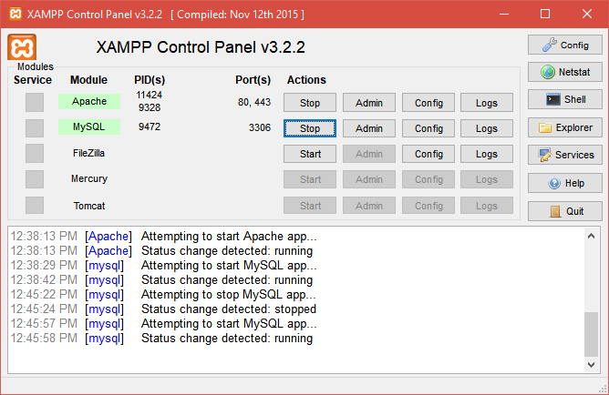

**LANGUAGE USED**

HTML:-

**The HyperText Markup Language or HTML is the standard**[**markup language**](https://en.wikipedia.org/wiki/Markup_language)**for documents designed to be displayed in a**[**web browser**](https://en.wikipedia.org/wiki/Web_browser)**. It can be assisted by technologies such as**[**Cascading Style Sheets**](https://en.wikipedia.org/wiki/Cascading_Style_Sheets)**(CSS) and**[**scripting languages**](https://en.wikipedia.org/wiki/Scripting_language)**such as**[**JavaScript**](https://en.wikipedia.org/wiki/JavaScript)**.**

[**Web browsers**](https://en.wikipedia.org/wiki/Web_browser)**receive HTML documents from a**[**web server**](https://en.wikipedia.org/wiki/Web_server)**or from local storage and**[**render**](https://en.wikipedia.org/wiki/Browser_engine)**the documents into multimedia web pages. HTML describes the structure of a**[**web page**](https://en.wikipedia.org/wiki/Web_page)[**semantically**](https://en.wikipedia.org/wiki/Semantic_Web)**and originally included cues for the appearance of the document.**

[**HTML elements**](https://en.wikipedia.org/wiki/HTML_element)**are the building blocks of HTML pages. With HTML constructs,**[**images**](https://en.wikipedia.org/wiki/HTML_element#Images_and_objects)**and other objects such as**[**interactive forms**](https://en.wikipedia.org/wiki/Fieldset)**may be embedded into the rendered page. HTML provides a means to create**[**structured documents**](https://en.wikipedia.org/wiki/Structured_document)**by denoting structural**[**semantics**](https://en.wikipedia.org/wiki/Semantics)**for text such as headings, paragraphs, lists,**[**links**](https://en.wikipedia.org/wiki/Hyperlink)**, quotes and other items. HTML elements are delineated by *tags*, written using**[**angle brackets**](https://en.wikipedia.org/wiki/Bracket#Angle_brackets)**. Tags such as <img /> and <input /> directly introduce content into the page. Other tags such as <p> surround and provide information about document text and may include other tags as sub-elements. Browsers do not display the HTML tags but use them to interpret the content of the page.**

**HTML can embed programs written in a**[**scripting language**](https://en.wikipedia.org/wiki/Scripting_language)**such as**[**JavaScript**](https://en.wikipedia.org/wiki/JavaScript)**, which affects the behavior and content of web pages. Inclusion of CSS defines the look and layout of content. The**[**World Wide Web Consortium**](https://en.wikipedia.org/wiki/World_Wide_Web_Consortium)**(W3C), former maintainer of the HTML and current maintainer of the CSS standards, has encouraged the use of CSS over explicit presentational HTML since 1997.**[**[2]**](https://en.wikipedia.org/wiki/HTML#cite_note-deprecated-2)**A form of HTML, known as**[**HTML5**](https://en.wikipedia.org/wiki/HTML5)**, is used to display video and audio, primarily using the <canvas> element, in collaboration with javascript.**

**CSS:-**

Cascading Style Sheets (CSS) is a [style sheet language](https://en.wikipedia.org/wiki/Style_sheet_language) used for describing the [presentation](https://en.wikipedia.org/wiki/Presentation_semantics) of a document written in a [markup language](https://en.wikipedia.org/wiki/Markup_language) such as [HTML](https://en.wikipedia.org/wiki/HTML).[[1]](https://en.wikipedia.org/wiki/CSS#cite_note-1) CSS is a cornerstone technology of the [World Wide Web](https://en.wikipedia.org/wiki/World_Wide_Web), alongside HTML and [JavaScript](https://en.wikipedia.org/wiki/JavaScript).[[2]](https://en.wikipedia.org/wiki/CSS#cite_note-2)

CSS is designed to enable the separation of presentation and content, including [layout](https://en.wikipedia.org/wiki/Page_layout), [colors](https://en.wikipedia.org/wiki/Color), and [fonts](https://en.wikipedia.org/wiki/Typeface).[[3]](https://en.wikipedia.org/wiki/CSS#cite_note-3) This separation can improve content [accessibility](https://en.wikipedia.org/wiki/Accessibility); provide more flexibility and control in the specification of presentation characteristics; enable multiple [web pages](https://en.wikipedia.org/wiki/Web_page) to share formatting by specifying the relevant CSS in a separate .css file, which reduces complexity and repetition in the structural content; and enable the .css file to be [cached](https://en.wikipedia.org/wiki/Cache_(computing)) to improve the page load speed between the pages that share the file and its formatting.

Separation of formatting and content also makes it feasible to present the same markup page in different styles for different rendering methods, such as on-screen, in print, by voice (via speech-based browser or [screen reader](https://en.wikipedia.org/wiki/Screen_reader)), and on [Braille-based](https://en.wikipedia.org/wiki/Braille_display) tactile devices. CSS also has rules for alternate formatting if the content is accessed on a [mobile device](https://en.wikipedia.org/wiki/Mobile_device).[[4]](https://en.wikipedia.org/wiki/CSS#cite_note-4)

The name *cascading* comes from the specified priority scheme to determine which style rule applies if more than one rule matches a particular element. This cascading priority scheme is predictable.

The CSS specifications are maintained by the [World Wide Web Consortium](https://en.wikipedia.org/wiki/World_Wide_Web_Consortium) (W3C). Internet media type ([MIME type](https://en.wikipedia.org/wiki/MIME_media_type)) text/css is registered for use with CSS by RFC 2318 (March 1998). The W3C operates a free [CSS validation service](https://en.wikipedia.org/wiki/W3C_Markup_Validation_Service#CSS_validation) for CSS documents.[[5]](https://en.wikipedia.org/wiki/CSS#cite_note-5)

In addition to HTML, other markup languages support the use of CSS including [XHTML](https://en.wikipedia.org/wiki/XHTML), [plain XML](https://en.wikipedia.org/wiki/Plain_Old_XML), [SVG](https://en.wikipedia.org/wiki/Scalable_Vector_Graphics), and [XUL](https://en.wikipedia.org/wiki/XUL)..

**JAVASCRIPT:-**

JavaScript ,[[10]](https://en.wikipedia.org/wiki/JavaScript#cite_note-10) often abbreviated JS, is a [programming language](https://en.wikipedia.org/wiki/Programming_language) that is one of the core technologies of the [World Wide Web](https://en.wikipedia.org/wiki/World_Wide_Web), alongside [HTML](https://en.wikipedia.org/wiki/HTML) and [CSS](https://en.wikipedia.org/wiki/CSS).[[11]](https://en.wikipedia.org/wiki/JavaScript#cite_note-11) Over 97% of [websites](https://en.wikipedia.org/wiki/Website) use JavaScript on the [client](https://en.wikipedia.org/wiki/Client_(computing)) side for [web page](https://en.wikipedia.org/wiki/Web_page) behavior,[[12]](https://en.wikipedia.org/wiki/JavaScript#cite_note-deployedstats-12) often incorporating third-party [libraries](https://en.wikipedia.org/wiki/Library_(computing)).[[13]](https://en.wikipedia.org/wiki/JavaScript#cite_note-lib_usage-13) All major [web browsers](https://en.wikipedia.org/wiki/Web_browser) have a dedicated [JavaScript engine](https://en.wikipedia.org/wiki/JavaScript_engine) to execute the [code](https://en.wikipedia.org/wiki/Source_code) on [users](https://en.wikipedia.org/wiki/User_(computing))' devices.

JavaScript is a [high-level](https://en.wikipedia.org/wiki/High-level_programming_language), often [just-in-time compiled](https://en.wikipedia.org/wiki/Just-in-time_compilation) language that conforms to standard.[[14]](https://en.wikipedia.org/wiki/JavaScript#cite_note-tc39-14) It has [dynamic typing](https://en.wikipedia.org/wiki/Dynamic_typing), [prototype-based](https://en.wikipedia.org/wiki/Prototype-based_programming) [object-orientation](https://en.wikipedia.org/wiki/Object-oriented_programming), and [first-class functions](https://en.wikipedia.org/wiki/First-class_function). It is [multi-paradigm](https://en.wikipedia.org/wiki/Programming_paradigm), supporting [event-driven](https://en.wikipedia.org/wiki/Event-driven_programming), [functional](https://en.wikipedia.org/wiki/Functional_programming), and [imperative](https://en.wikipedia.org/wiki/Imperative_programming) [programming styles](https://en.wikipedia.org/wiki/Programming_paradigm). It has [application programming interfaces](https://en.wikipedia.org/wiki/Application_programming_interface) (APIs) for working with text, dates, [regular expressions](https://en.wikipedia.org/wiki/Regular_expression), standard [data structures](https://en.wikipedia.org/wiki/Data_structure), and the [Document Object Model](https://en.wikipedia.org/wiki/Document_Object_Model) (DOM).

The ECMAScript standard does not include any [input/output](https://en.wikipedia.org/wiki/Input/output) (I/O), such as [networking](https://en.wikipedia.org/wiki/Computer_network), [storage](https://en.wikipedia.org/wiki/Data_storage), or [graphics](https://en.wikipedia.org/wiki/Computer_graphics) facilities. In practice, the web browser or other [runtime system](https://en.wikipedia.org/wiki/Runtime_system) provides JavaScript APIs for I/O.JavaScript engines were originally used only in web browsers, but are now core components of some [servers](https://en.wikipedia.org/wiki/Server_(computing)) and a variety of [applications](https://en.wikipedia.org/wiki/Application_software). The most popular runtime system for this usage is [Node.js](https://en.wikipedia.org/wiki/Node.js).

**Modules**

1. **Admin authentication**

This module is mainly based on admin. System will check the admin user name and password for authentication. After the verification for authorization the admin can be able to precede the process. All works are done under his control.

1. **User Registration**

This module covers the details about the registration of users which they can be register by itself by adding data like name, password, email id and further details. After registration they can be sign in by their username and password.

**ER Diagram** 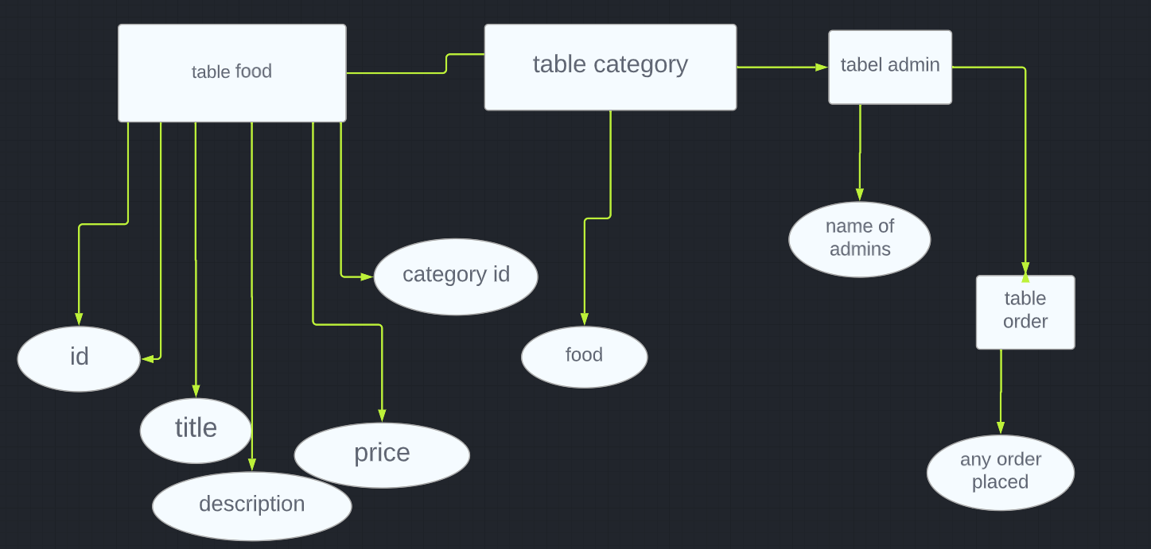

**Project Design:**

**1.website:-**

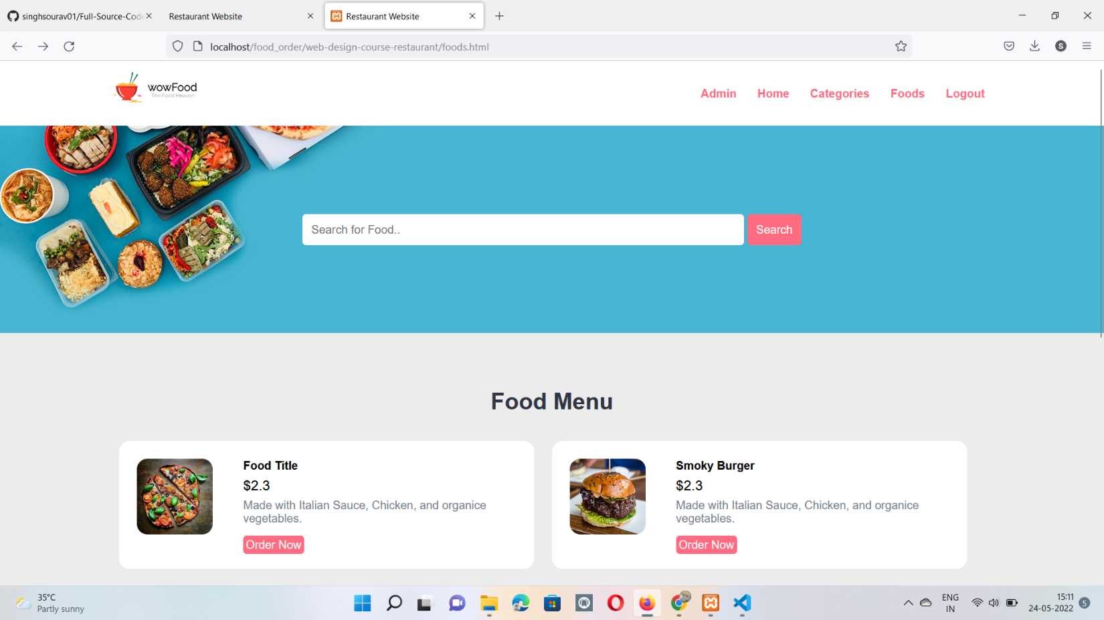

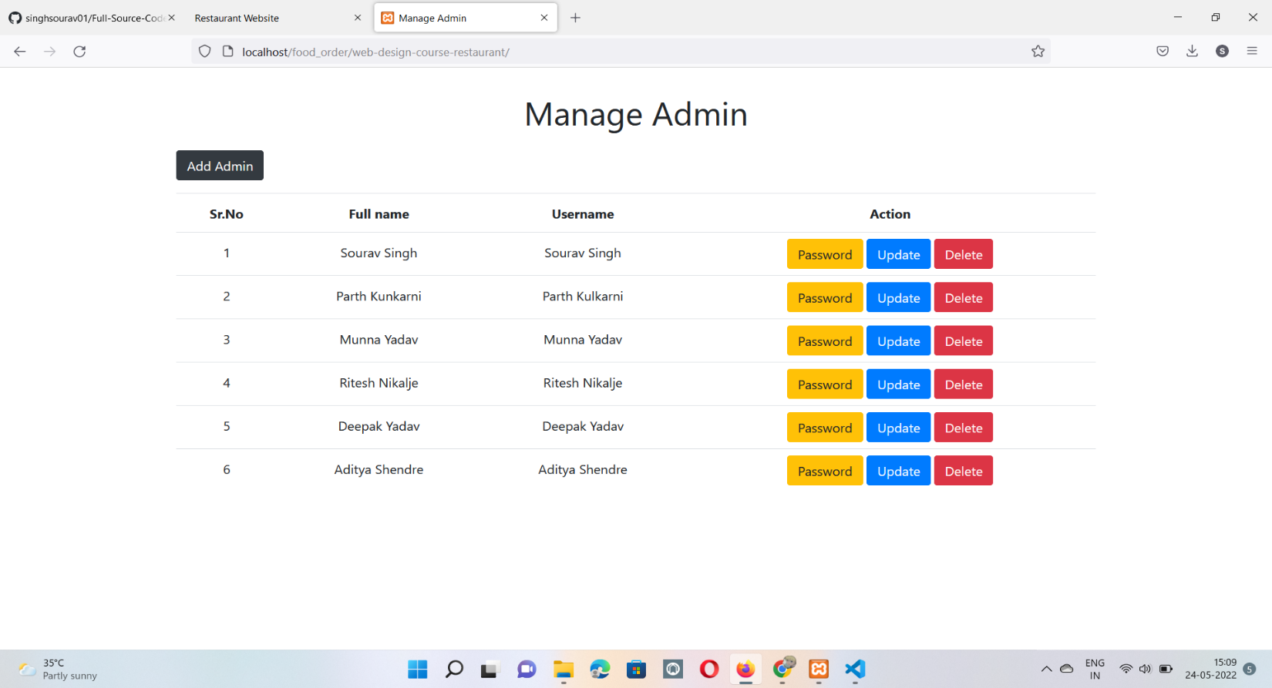

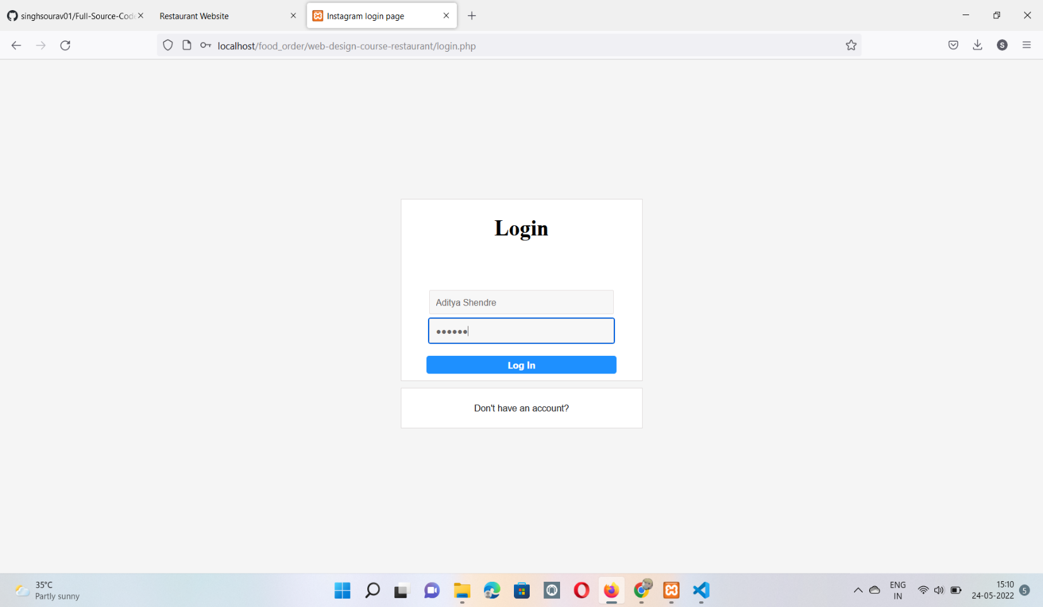

**2.Database design:-**

